CIS 581

Rishabh Jain

1/18/2019

**LAB 1**

Q3 Data Type : smalldatetime

Identity coulmn : InvoiceId

Q4:

After pressing F5, I got this output as the query executed.

By * we selected the entire content.

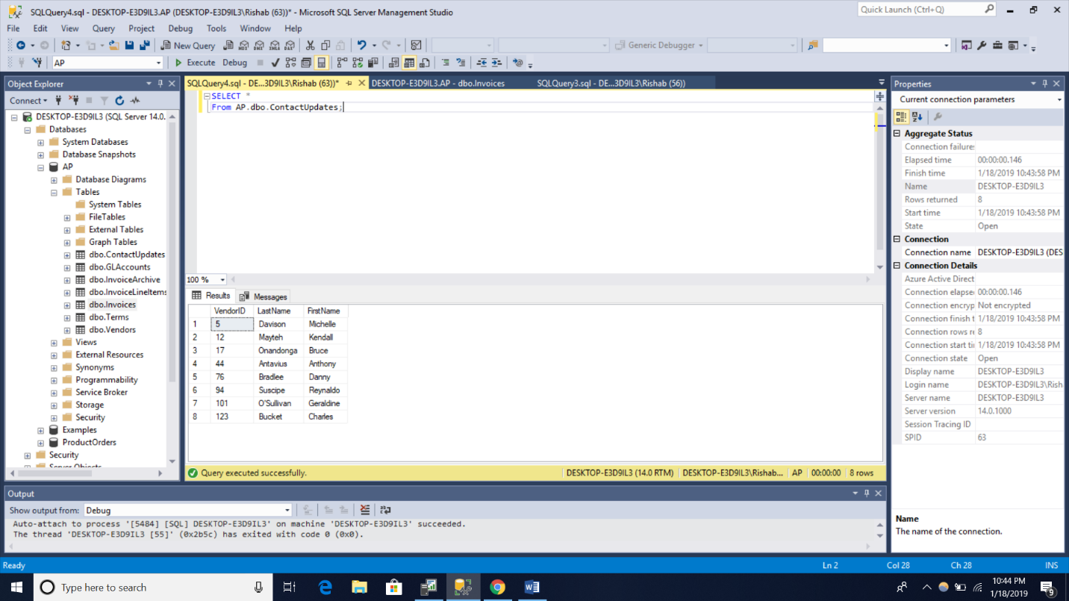

Q5:

The Execute Query toolbar button produces the same result as F5 button as it executes the query.

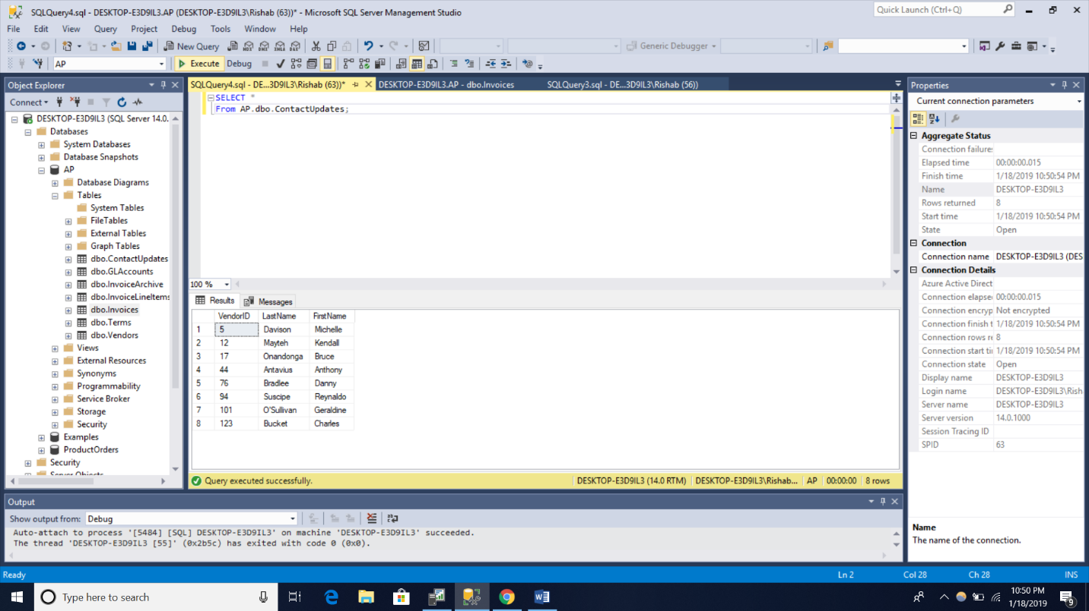

Remarks:

Great introductory lab to get the software setup done. The knowledge of words like identity key and datatype helped to familiarize with the SQL. Finally the two ways to run the query F5 and toolbar query button was informational too on how to see results of query.